The Tapa Co. - Mobile MVP
User journey map - home to checkout, by category
Mobile-first scope - 8 to 12 month build. Each row marks where to paste the corresponding screen image. Rev. 2 - reflects design pass feedback.

0. Home and navigation (shared entry point)
Every category journey below starts from this shared entry point. Reference screens below are from the latest visual design pass.
Step | Screen | What happens / [SCREEN TO PASTE] |  | User action
0.1 | Home screen | Off-white background. Notification bell icon in header. Rotating hero carousel - "Today's Ritual" (dot pagination). 4 category cards with icon badges - Ritual Guides, Panchang, Purohit & Puja, Bhajan Mandali. |  | Tap a category card, hamburger icon, or bell
0.2 | Hamburger menu | Accordion menu - 4 parent categories expand into sub-categories. Panchang's row is a flipping block showing today's panchang inline (live data inside the nav). About and Contact sit in a footer block at the bottom.  BUILD NOTE - live/animated data inside a static nav row needs separate technical scoping |  | Tap a category or sub-category
0.3 | Search results | Results grouped by type with thumbnail imagery - Ritual Guides, Book a Puja, Downloadable - each card shows a small preview image. |  | Tap a result
0.4 | Search - no results | Empty state with spelling-corrected suggestions and popular searches. |  | Tap a suggestion or retype
0.5 | Login - phone + OTP | Phone number entry, 6-digit OTP verification with resend timer. Triggered when an action needs an account (save, book, subscribe). |  | Enter number, verify OTP
0.6 | Account / profile | Saved rituals count, bookings count, subscription status shown as 3 stat tiles. Separate rows below for Saved Rituals, Booking History, My Subscriptions, Language, Notification Preferences, Help & Support, Log out. |  | Tap into any row
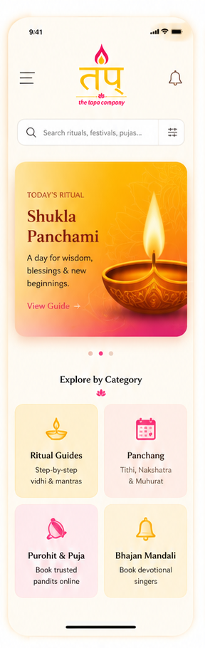  0.1 - Home screen |  |  | 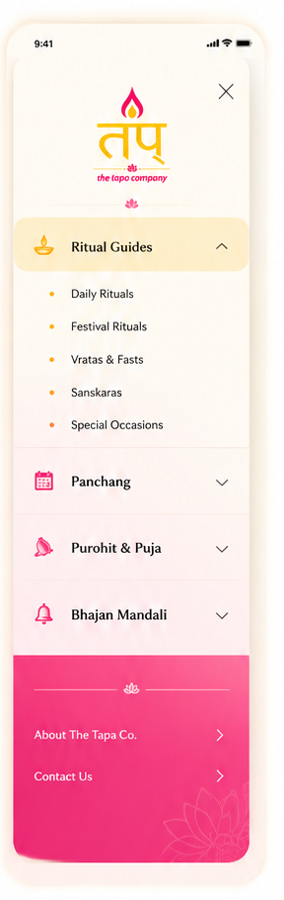  0.2 - Hamburger menu

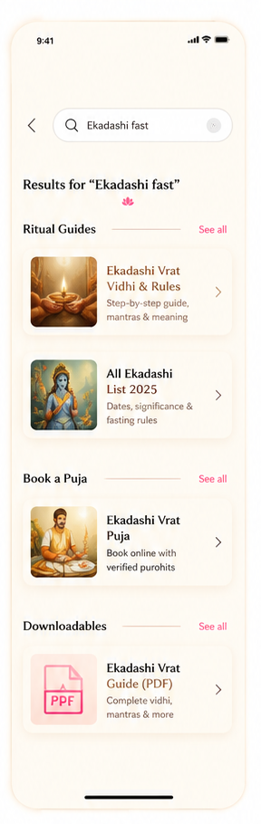  0.3 - Search results | 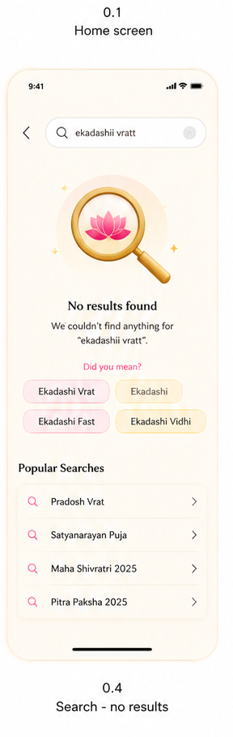  0.4 - Search - no results

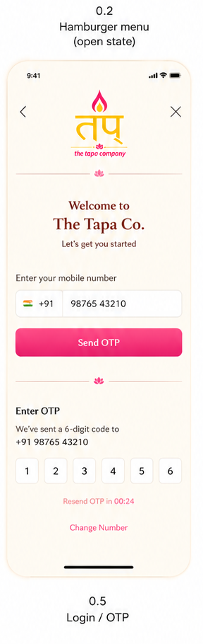  0.5 - Login / OTP | 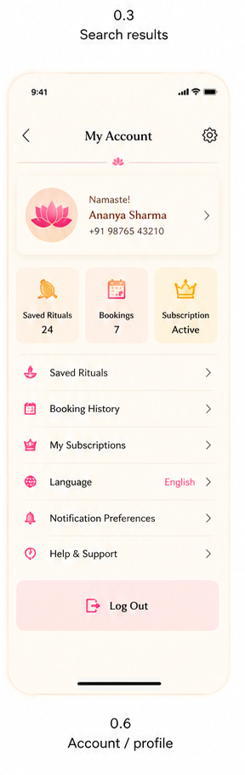  0.6 - Account / profile

1. Ritual Guides journey
Editorial / trust layer. Two commerce exits now live directly on the article page - a standalone Ritual Kit purchase, and a handoff to Purohit & Puja.
Step | Screen | What happens / [SCREEN TO PASTE] | User action
1.1 | Category landing | Sub-category tabs - Festive Pujans / All-year Pujans / Navagraha Pujans. Ritual cards with classification tag (Dharma / Pratha / etc). [SCREEN: Ritual Guides landing] | Tap a sub-category tab, then a ritual card
1.2 | Article page - top | Language toggle (EN / हिं) and Listen audio option under the title. Two side-widget buttons appear at this level - "Download ritual card" and "Buy a Ritual Kit (for this puja)". Source + confidence score. [SCREEN: Ritual Guides article - top]  Buy a Ritual Kit here is a STANDALONE kit purchase - self-service, no pandit. Distinct SKU from the pandit-bundled kit in section 3. | Toggle language, tap Listen, tap a widget button
1.3 | Standalone kit checkout | New flow - tapping "Buy a Ritual Kit" opens a lightweight checkout - kit contents list, price, quantity, delivery address, pay. No pandit, no date/time slot. [SCREEN: Standalone ritual kit checkout - NOT YET DESIGNED]  CHECKOUT STEP - new flow, needs its own screens | Review contents, enter address, pay
1.4 | Article page (cont.) | Step-by-step vidhi. Samagri checklist card - collapsible download row. WhatsApp subscription nudge card. [SCREEN: Ritual Guides article - vidhi + samagri + nudge] | Scroll vidhi, tap download, or tap subscription nudge
1.5 | Bottom CTA | "Need a purohit for this puja?" - bottom-anchored, appears after content, not above the fold. [SCREEN: Ritual Guides article - bottom CTA] | Tap to exit into Purohit & Puja journey (see section 3)
1.6 | End state | Journey ends at: kit purchased (checkout above), PDF downloaded, article read/saved, or handoff to booking. | Journey complete, or continue to Purohit & Puja or kit checkout
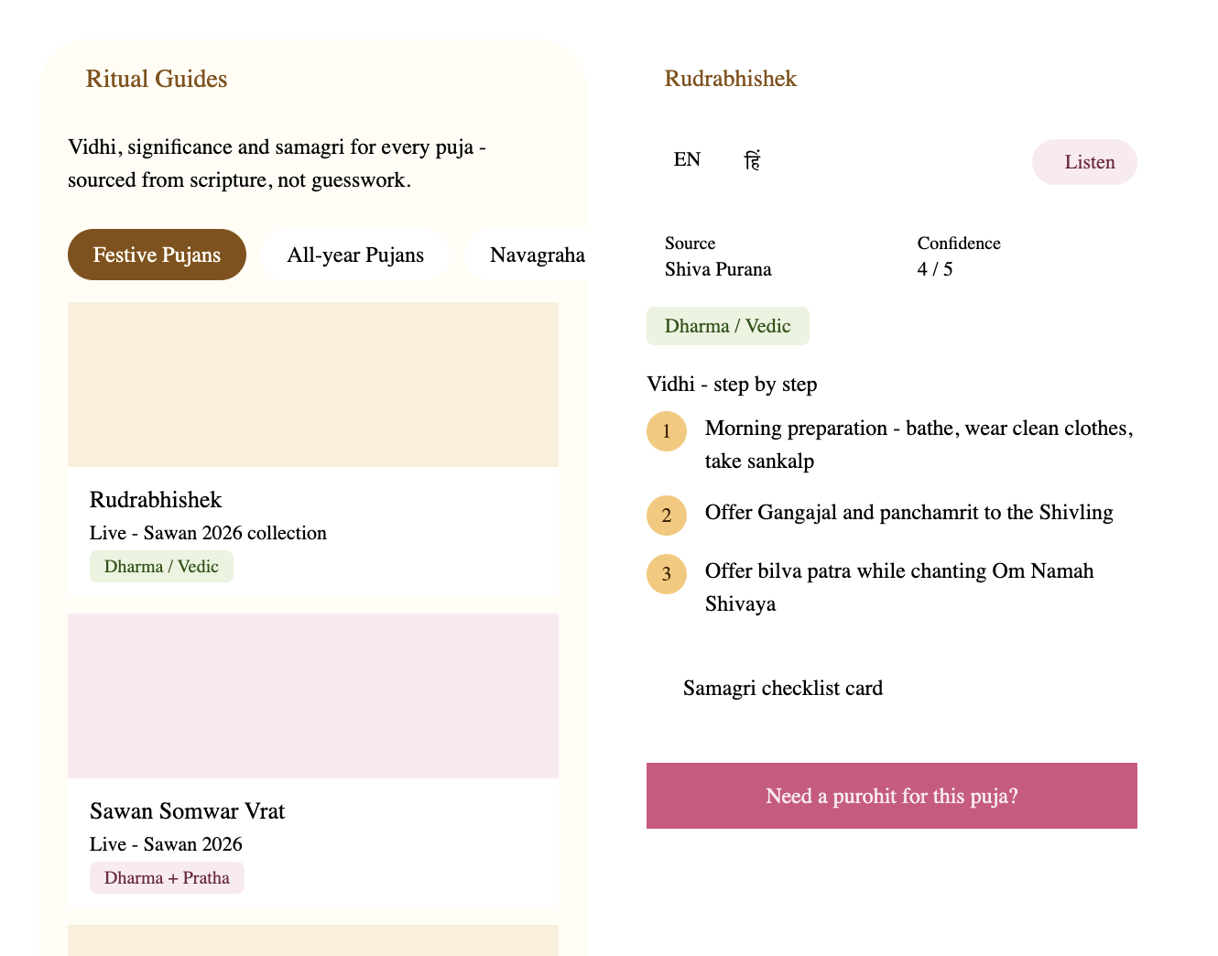
[PASTE: Ritual Guides landing + Article page]

2. Panchang journey
Utility / data layer. No checkout - ends in a calendar download or a subscription opt-in.
Step | Screen | What happens / [SCREEN TO PASTE] | User action
2.1 | Category landing | Live "today" snapshot - tithi, paksha, nakshatra, sunrise. WhatsApp subscription nudge below it. 4 sub-category cards below that. [SCREEN: Panchang landing] | Tap a sub-category card
2.2 | Vrat Calendar list | Filter chips - All / Ekadashi / Pradosh. Each entry shows date + countdown chip ("In 5 days"). [SCREEN: Vrat Calendar list] | Tap a filter, or tap a vrat entry
2.3 | Vrat detail page | Individual vrat date page - not yet designed in detail. Placeholder. [SCREEN: Vrat detail page] | View detail, or download
2.4 | Bottom CTA | "Download full 2026 calendar" - PDF download CTA at the bottom of the list. | Tap to download PDF
2.5 | End state | No checkout in this category. Journey ends at: PDF downloaded, date checked, or subscription opt-in (see section 5). | Journey complete, or continue to subscription
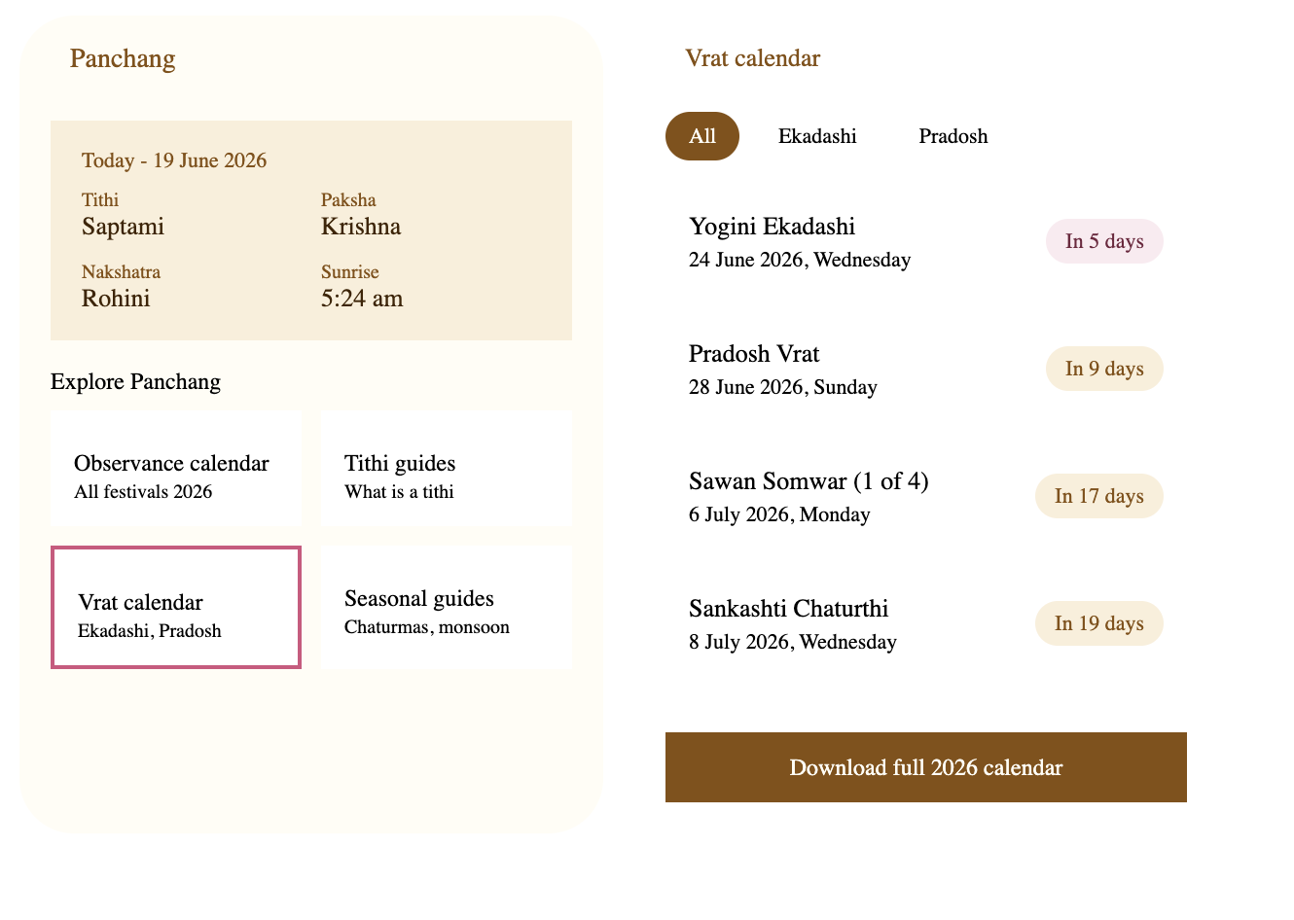
[PASTE: Panchang landing + Vrat Calendar list]

3. Purohit & Puja journey (checkout flow)
Booking and commerce layer. Pricing updated. Pandit selection now bundles kit + havan kit together, plus a WhatsApp escape hatch for live chat mid-booking.
Step | Screen | What happens / [SCREEN TO PASTE] | User action
3.1 | Category landing | List of 4-5 pujas as rows - icon, title, variant hint, chevron. Rudrabhishek, Satyanarayan Katha, Musical Mandali, Navratri Ghatsthapna. [SCREEN: Purohit & Puja landing] | Tap a puja row
3.2 | Puja detail page | Language + Listen toggle. Variant cards - Sankshipt ₹7,100 vs Vistrit ₹14,000 - with duration. Condensed vidhi preview. Samagri included row. [SCREEN: Puja detail - variant selection]  Pricing updated from earlier draft - confirm these are final | Select a variant, review vidhi
3.3 | Pandit + kit selection | Pandit cards with rating + language spoken. Includes samagri kit, pandit, and havan kit as one bundle. Date and time slot fields. "Wish to chat?" button opens WhatsApp chat directly. [SCREEN: Pandit + kit selection] | Select pandit, pick date/time, or tap Wish to chat
3.4 | Checkout / confirm | Final CTA shows price inline - "Confirm booking - ₹7,100". [SCREEN: Confirm booking screen]  CHECKOUT STEP | Tap to confirm and pay
3.5 | Booking confirmed | Success state with booking summary. WhatsApp subscription nudge appears here (high-intent moment). [SCREEN: Booking confirmed + nudge] | Tap subscription nudge, or view booking details
3.6 | End state | Booking saved to account under Booking history (see section 0.6). | Journey complete
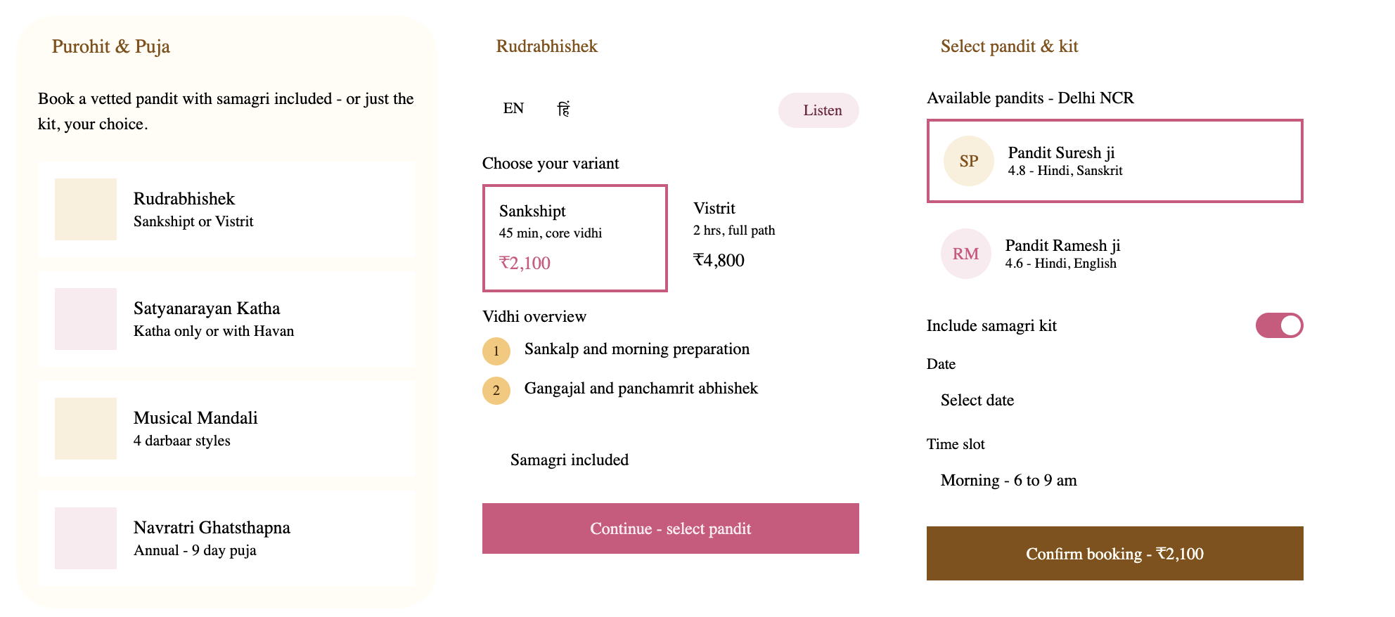
[PASTE: Purohit & Puja landing + variant selection + pandit/kit selection - note: pricing in this image is outdated, update to ₹7,100 / ₹14,000]

4. Bhajan Mandali journey (checkout flow)
Booking and commerce layer. Now includes a WhatsApp chat fallback for mandali types not on the list.
Step | Screen | What happens / [SCREEN TO PASTE] | User action
4.1 | Category landing | 6 mandali types as a single vertical list - Sundarkand, Mata Ki Chowki, Shyam Darbaar, Ram Darbaar, Shiva Stotra Satsang, Generic mix. "Your choice not listed? Chat with us" button opens WhatsApp. [SCREEN: Bhajan Mandali landing] | Tap a mandali type, or tap Chat with us
4.2 | Detail + booking page | Single page - "what's included" list, starting price, then Date / Venue / Expected guests fields together. [SCREEN: Mandali detail + booking fields] | Fill date, venue, guest count
4.3 | Checkout / confirm | "Check availability" CTA - request-based, not instant confirm (pending decision - confirm with team). [SCREEN: Check availability screen]  CHECKOUT STEP | Tap to submit request
4.4 | Booking confirmed | Success state with booking summary. WhatsApp subscription nudge appears here with generic copy (no recurring-date hook for mandali). [SCREEN: Mandali booking confirmed + nudge] | Tap subscription nudge, or view booking details
4.5 | End state | Booking saved to account under Booking history (see section 0.6). | Journey complete
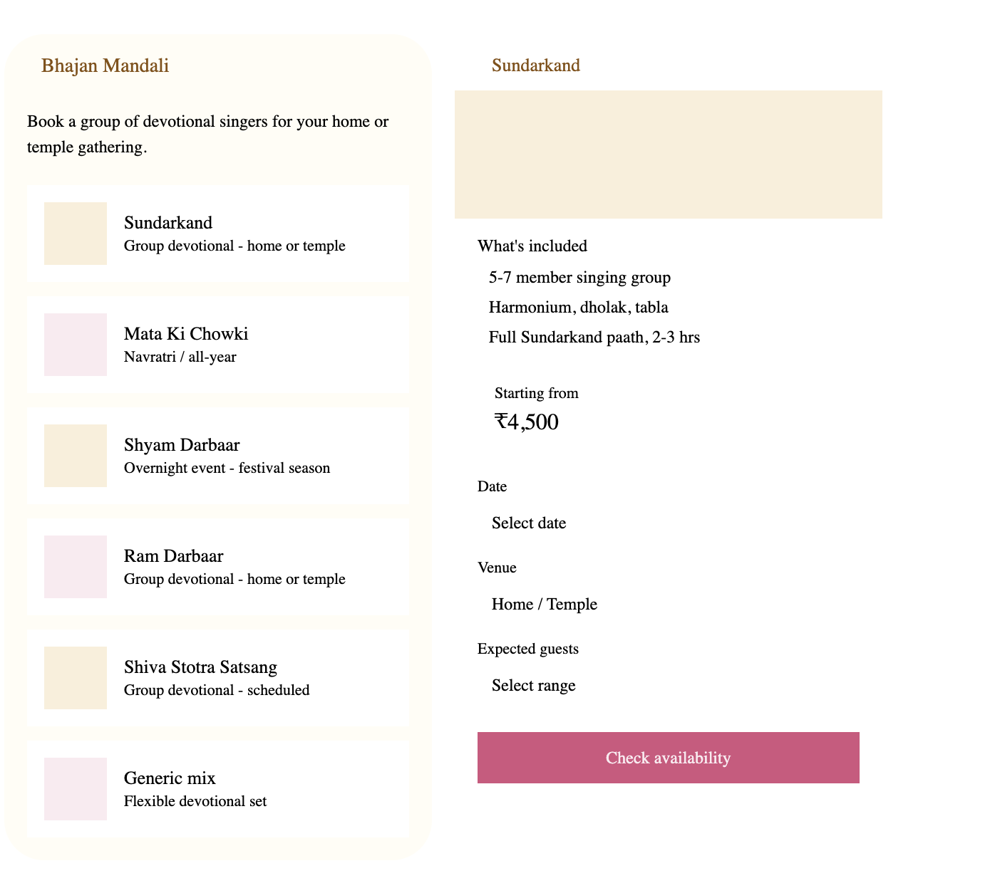
[PASTE: Bhajan Mandali landing + Sundarkand detail/booking - note: add "Your choice not listed? Chat with us" button to landing screen]

5. WhatsApp subscription journey (cross-cutting, checkout flow)
Persistent nudge across all 4 categories, disappearing after 2-3 impressions or once subscribed. Once subscribed, the subscriber also enters a recurring broadcast loop - see 5.6 below.
Step | Screen | What happens / [SCREEN TO PASTE] | User action
5.1 | Nudge - in context | Same component, contextual copy per placement. E.g. "Get reminded for every Ekadashi" on an article, generic on Panchang, high-emphasis post-booking. [SCREEN: Subscription nudge - any placement] | Tap the nudge card
5.2 | Opt-in screen | Value prop, price ₹99/year, WhatsApp number field, bullet list of what's included, consent line. [SCREEN: WhatsApp opt-in screen] | Enter number, tap Confirm & pay
5.3 | Payment method | UPI pre-selected, Card and Wallet/Netbanking as alternatives. Price shown again at top. [SCREEN: Payment method selection]  CHECKOUT STEP | Select method, tap Pay ₹99
5.4 | Payment success | Confirms active status and exact expiry date (1 year from signup). Directs user to check WhatsApp. [SCREEN: Subscription success screen] | Tap Back to home
5.5 | WhatsApp welcome message | First message - welcome + next concrete reminder date + opt-out instructions ("Reply STOP"). [SCREEN: WhatsApp welcome message] | Message received - reminders begin
5.6 | Recurring panchang broadcast | Ongoing - a panchang-based message is broadcast to the full subscriber database, same content for everyone (not personalized). Each message includes 3 action buttons - Complete Ritual Guide, Buy Ritual Kit, Book a Purohit. [SCREEN: WhatsApp panchang broadcast - NOT YET DESIGNED]  Tapping a button deep-links into the matching journey - section 1, the new kit checkout (1.3), or section 3 | Tap a button in WhatsApp
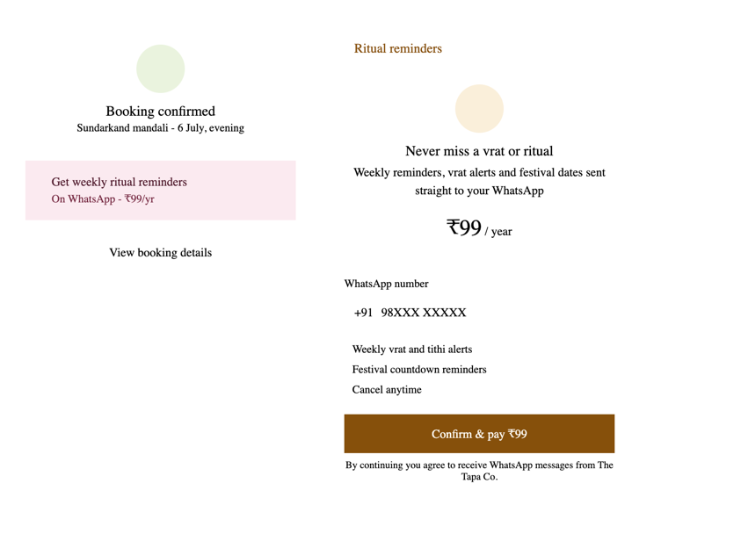
[PASTE: Subscription nudge component + placements across Ritual Guides, Panchang, post-booking]
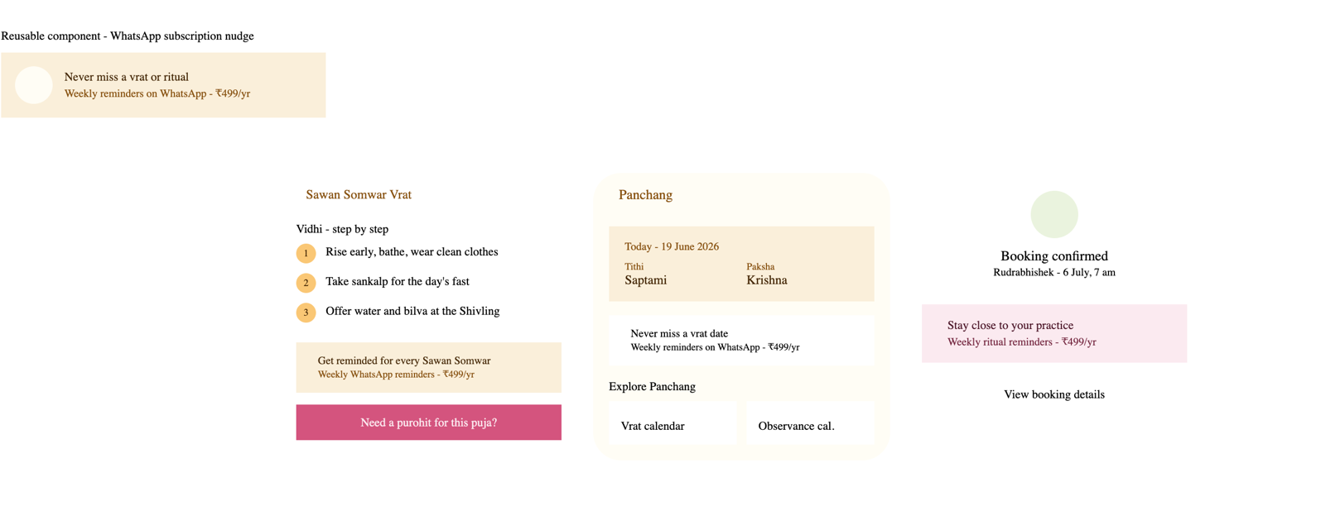
[PASTE: Opt-in screen + payment method + success screen]

Open items - not yet resolved
Flagged during this design pass. Needs a decision before dev handoff is final.
# | Item
1 | Save/bookmark action on the Ritual Guides article page - needed to feed the "Saved rituals" count on the account profile.
2 | Language setting conflict - account-level toggle vs per-article toggle. Pick one source of truth.
3 | Auto-renewal logic for the WhatsApp subscription - auto-charge next year, or lapse and require fresh opt-in.
4 | WhatsApp Business API vendor selection (e.g. Gupshup, Interakt) - needed for template approval, including the new recurring broadcast (5.6).
5 | Standalone Ritual Kit checkout (1.3) has no designed screens yet - contents list, quantity, delivery address, payment.
6 | Pandit language-matching against the app's Hindi/English toggle - not yet wired into pandit selection logic.
7 | Bhajan Mandali booking model - instant confirm vs request-based ("Check availability") - changes the post-submit flow.
8 | Error / empty states (no internet, no pandits available in city, payment failed) - explicitly deferred, not in this pass.
9 | Panchang menu row "flipping block" (0.2) showing live today's-panchang inside the nav - needs technical scoping for an animated/live-data nav element.
10 | Recurring panchang broadcast (5.6) - confirm send frequency (daily/weekly), and confirm the 3 action buttons deep-link correctly per subscriber's relevant puja/kit.

